Troubleshooting Oracle Listener

Oracle Database Service Name Not Appearing in Listener Services List
When the listener is up and running but you can’t connect to the database and receive the error warning that the listener does not know of service, one possibility could be that neither the database service nor net service(s) particular to the database are registered with the listener
Step 1: Check the listener services summary list to see if the database service is registered with the listener
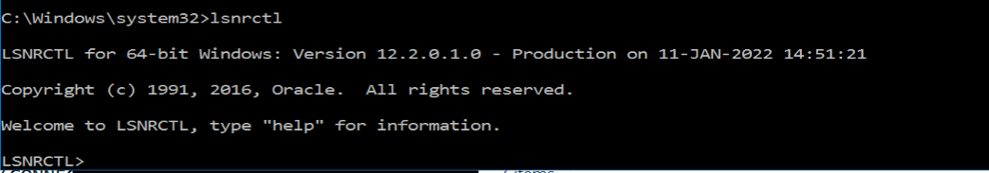
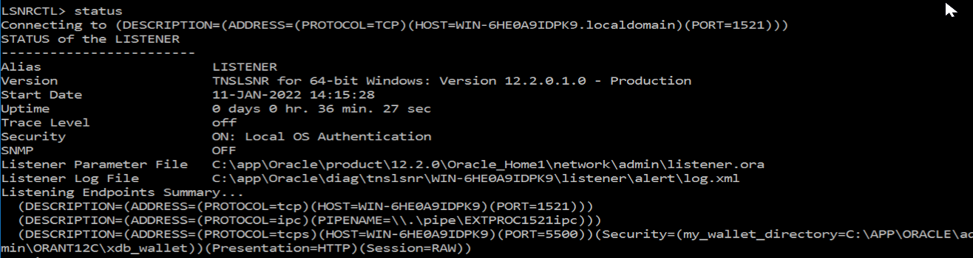
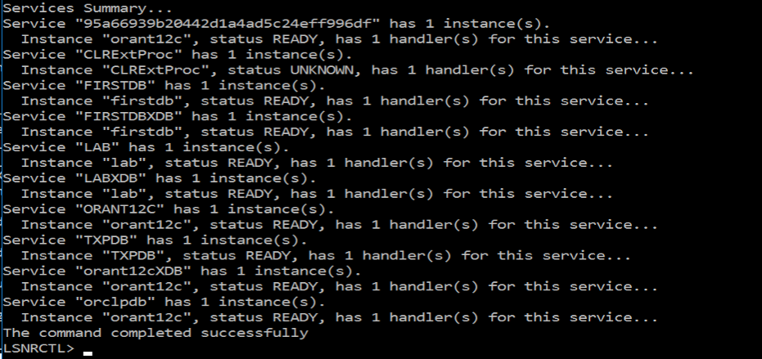

Step 2: Check the tnsnames.ora file to see that the net service name is resolved to a descriptor that contains the correct address info for an available listener. Alternatively, you could have checked Oracle Net Manager. In the previous images, both the CDB2 and EXAMDB database services are not shown in the listener services summary. Also check that the database service name in the “SERVICE_NAME” parameter of the tnsnames.ora file is correct
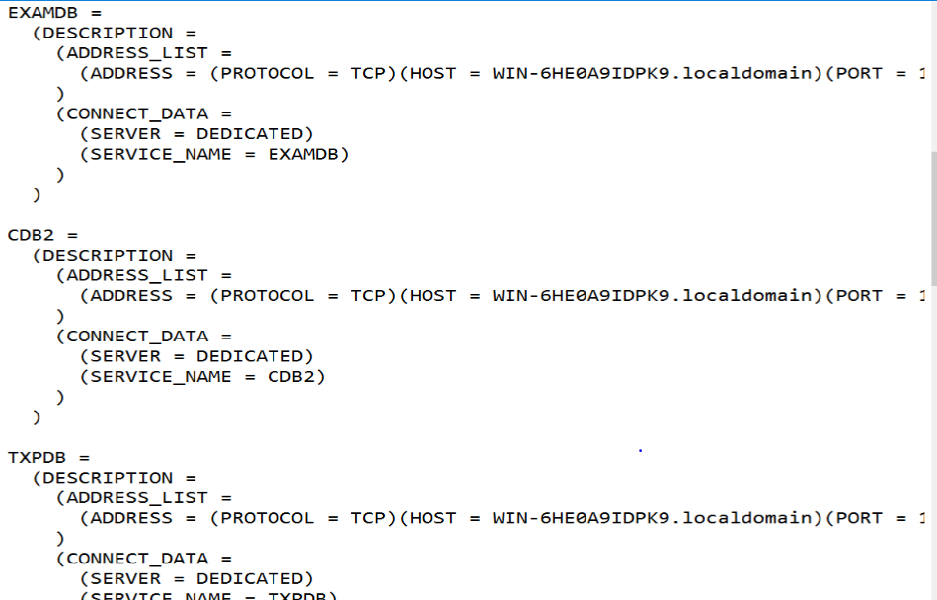
Using Net manager
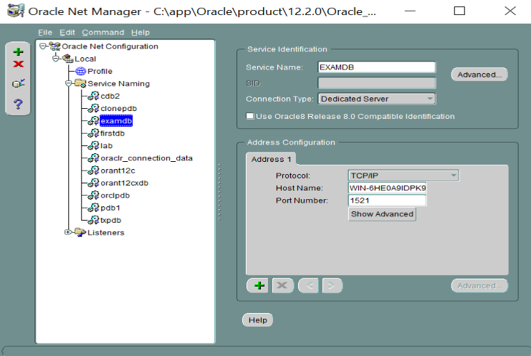

Step 3: Log into the database on server side (using the command line)
Set required environment variable, ORACLE_SID, and connect to the database as sys user
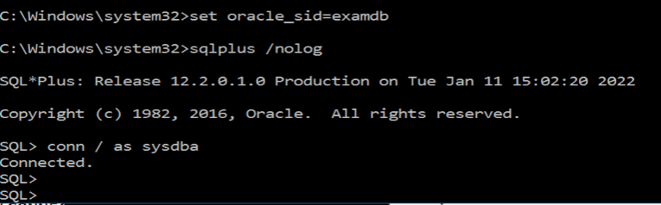
Step 4: Check the listener parameter 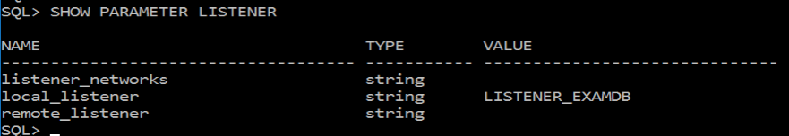
Step 5: You can dynamically change the set of net services which can facilitate connections to the database by using the ALTER SYSTEM command. At least one net service name should be listed here in order to have automatic database service registration with a listener (reload listener after change).
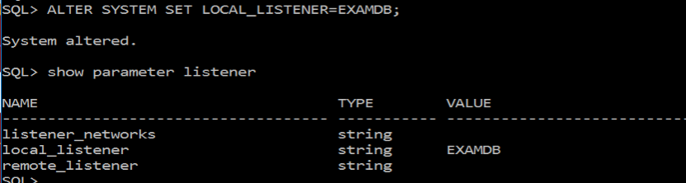
Step 6: Check to see if the database service name appears in the listener service summary list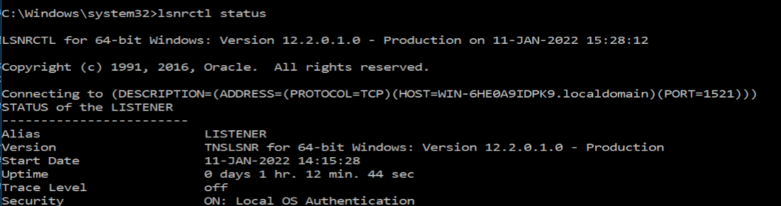
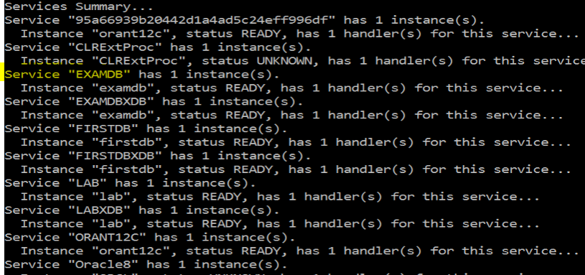
NOTE: To reset the local listener initialization parameter back to the database default use the following command
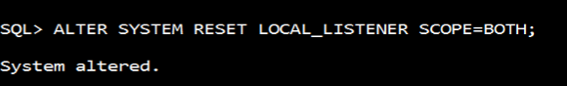

Using a Port other than 1521 (for TCP/IP) Or a protocol other than TCP/IP protocol

Method 1: create a new listener using Oracle Net Manger or by modifying the listener.ora file to include a new listener
Below is an image of a second listener “LISTENER2’ that was created in the listener.ora file using Oracle Net Manager. Listener2 uses TCP/IP protocol but uses port 1561 rather than the default port 1521
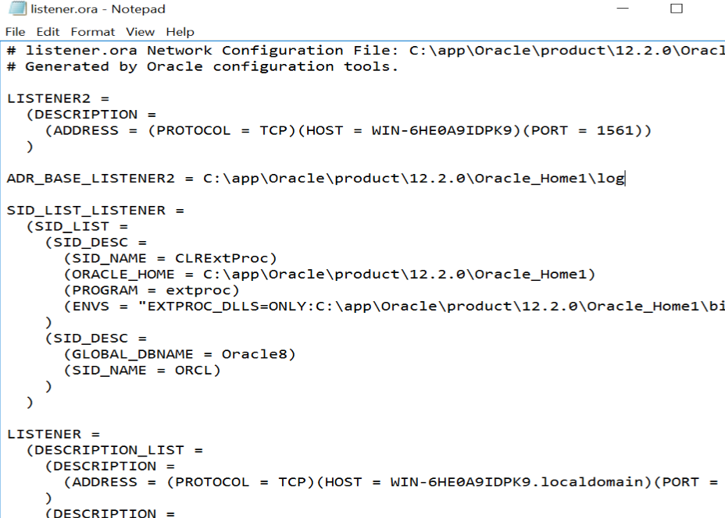
Enter the Oracle Home password (same password as password for creating new SIDs) that was setup at database installation
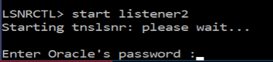
Go to the tnsnames.ora file and change the port number for the net service(s) that is associated with the database services that should use this listener, or add the address of the new listener to the net service address list.
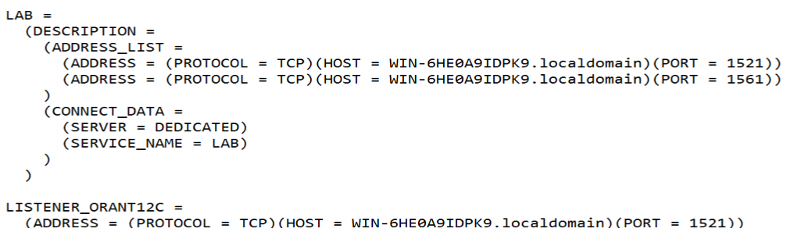

If the net services in the previous step has not been added to the local_listener parameter, connect to the database and use the ALTER SYSTEM command to add them to the local_listener parameter

Method 2: Change listener port number
STEP 1: Stop the listener either in Windows services or by issuing the listener control utility command

Using Windows services
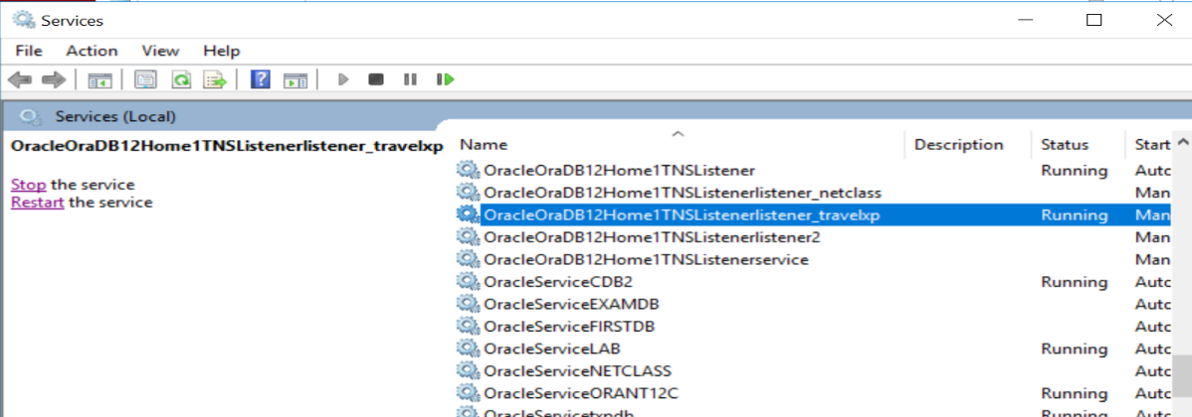

Using listener control utility
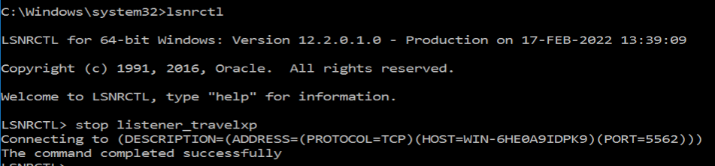
STEP 2: check to see available ports
Any port number that is not listed is available
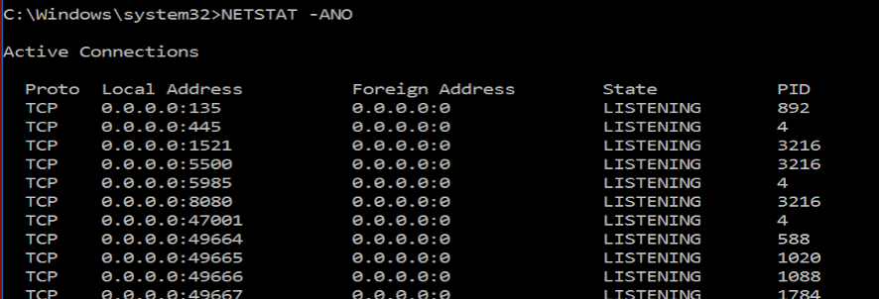
STEP 3: Modify listener.ora file to reflect the new port number that you want to use for the listener and save the file
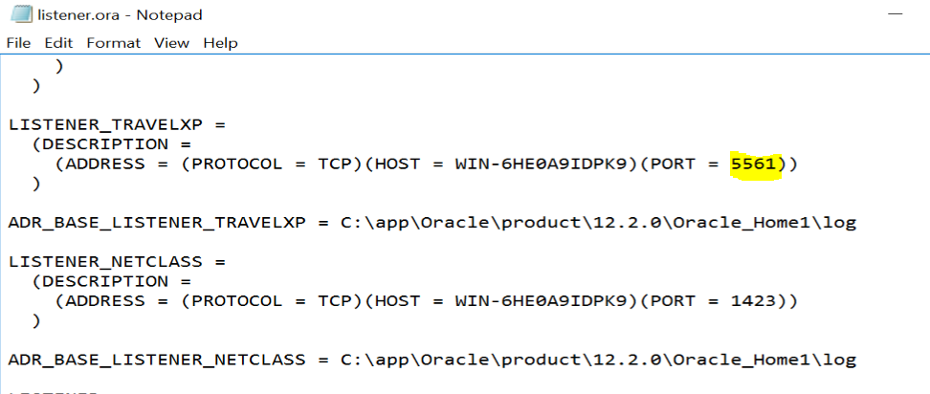

STEP 4: Modify the tsnnames.ora file to add the new listener port number to the net services that will be using the listener
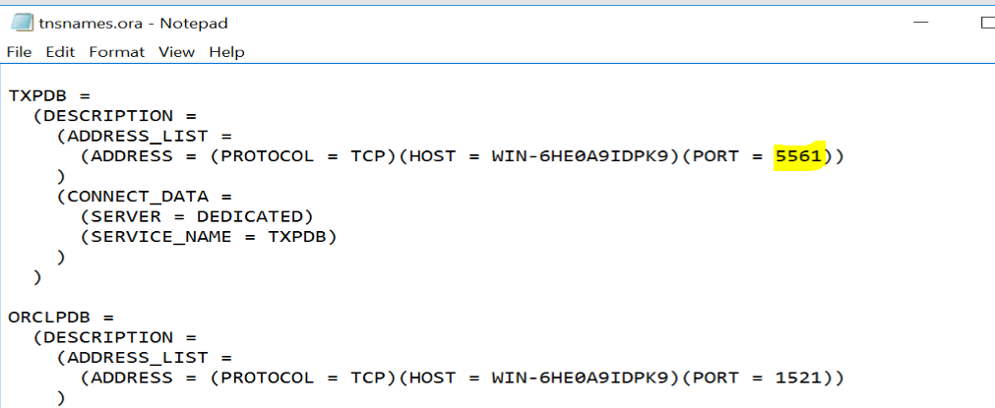

STEP 5: Start the listener either through Windows services or the listener control utility
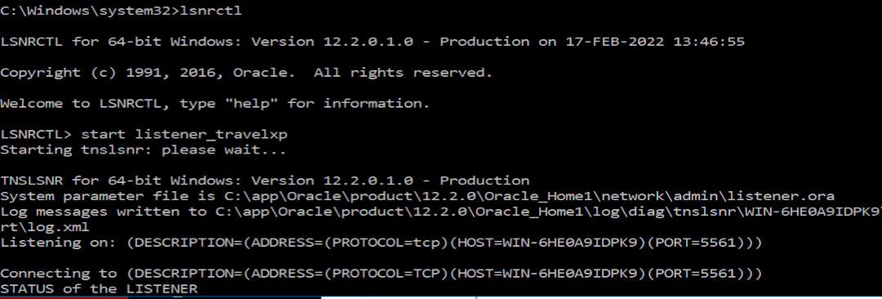

STEP 6: Register the database service as well as set up automatic service registration with the listener
Connect to the database and set the local listener parameter to the net service names (in tnsname.ora) that are associated with the database service name. This needs to be done every time a new listener is added to a net service address list or if the port number is changed
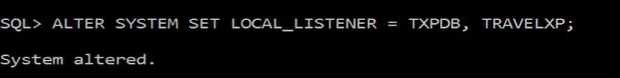
STEP 7: Check to see that the database service is registered with the listener
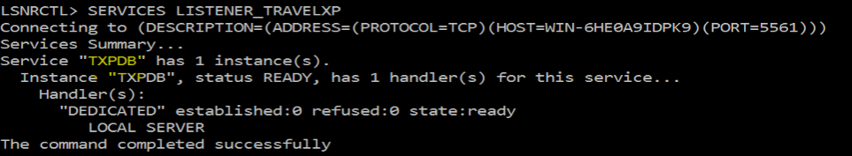

Adding a Local listener
Use a local listener (See Chapter 3, slide 3-20 of Oracle9i Database Administration Fundamentals II Ed 2.0.pdf)
Step 1: ensure that the local listener initialization parameter is set in the pfile. This is a dynamic parameter can alternatively be changed by using the ALTER SYSTEM command once connected to the database. The value placed in the local_listener parameter field is not actually a listener, but a net service name or a set of net service names. Therefore, it would need to be resolved in the tnsnames.ora file like all other net service names
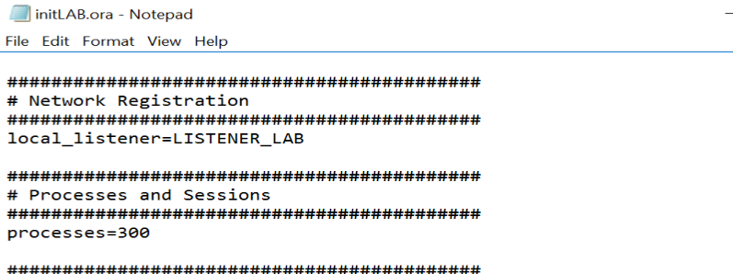
Step 2: Create a new listener with a different port number other than the default port number of 1521 for TCP/IP protocols if one does not already exist. Use the netstat -an command to find an available port. You may need to reboot the operating system to use lsnrctl utility to control newly created listener
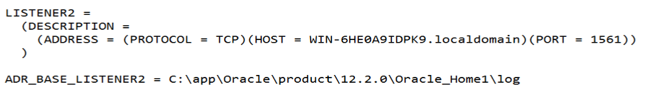
Step 3: Resolve the net services listed in the local_listener parameter in the tnsnames.ora file
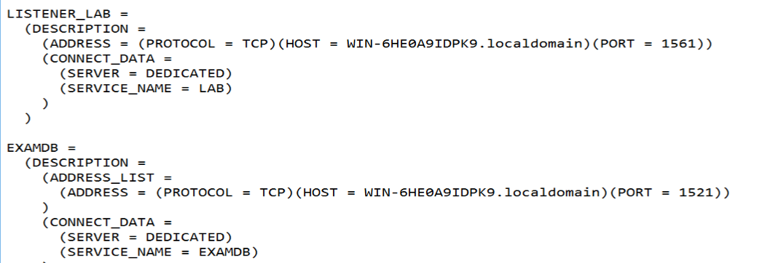

Step 4: If the net service was not originally listed in the pfile or the spfile used to startup the instance, connect to the database and change the local listener parameter to the net service names of the set of net services (in tnsnames.ora file) that are associated with the database service for the database. The service_name parameter contains the list of database service names for a database
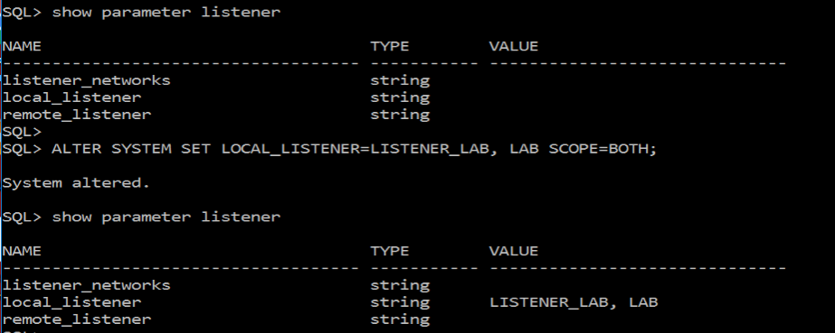
How to check if a port is available by entering the “netstat ano” or “netstat an” command. The ports listed here under “Local Address” are already in use. Choose a port that is not listed below. Last part of the local address is the port number. For example, for local address ‘0.0.0.0.1521’ the port is 1521, which the default port for TCP/IP protocol for the default oracle listener, LISTENER
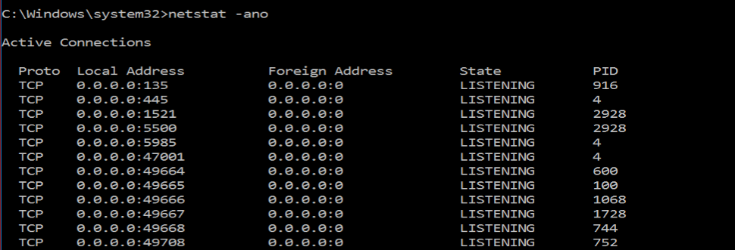

Error messages

Error message 1:

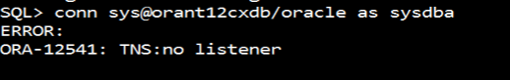
Possible Causes
- Listener is stopped, check the listener status (or windows services) and start listener if the listener is stopped
- The port number in the tnsnames.ora file for the net service might be incorrect (does not match any listener port number in listener.ora file for the given protocol)
- If it’s a shared server service name, check the listener services to ensure the dynamic port number matches the port number in the tnsnames.ora file

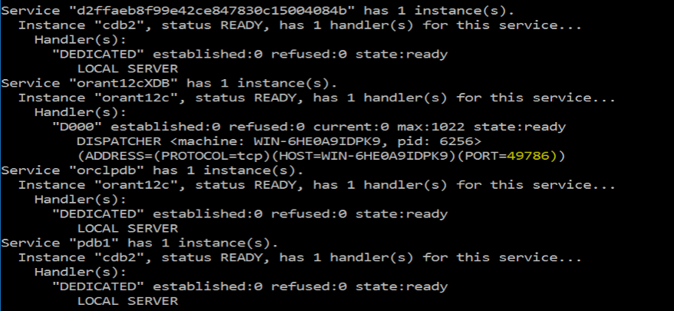
The port number for the database service orant12cxdb on the listener services list does not match the one below from the tnsnames.ora file
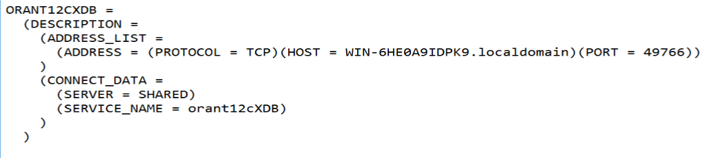

Change the port number to 49786, save the tnsnames.ora file and try to connect again
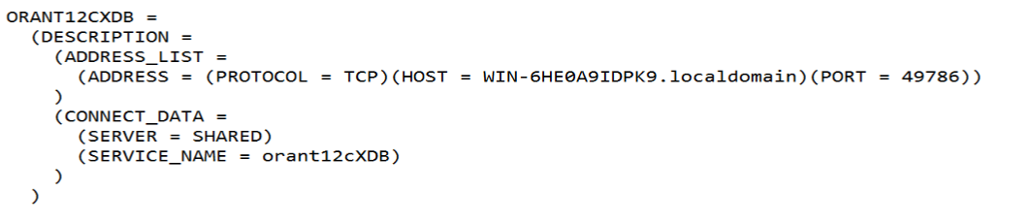


Error message 2:

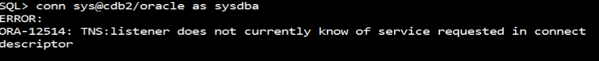
Solution 1
Refer to “Oracle Service Not in Listener Services Summary List”
Solution 2: if it’s a shared server service name, make sure the database service name in the tsnnames.ora file matches the shared server service name in the spfile
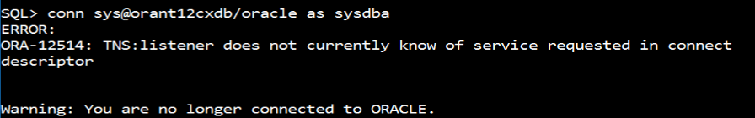

The database service name is shown below, assuming this is the pfile that was used to create the spfile. If not create a pfile from the spfile and view it to see the shared server service name
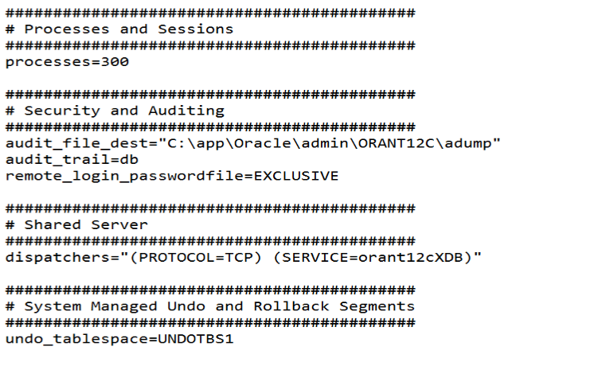
The database service name in the tnsnames.ora file (shown below) should be “orant12cXDB”
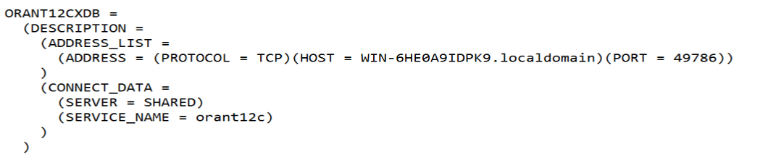
Change the service name, save the tnsnames.ora file and try to connect to the database again
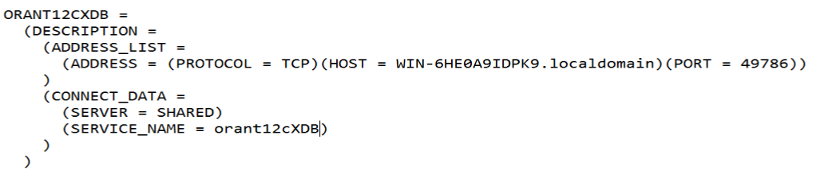
Orant12cXDB is a shared server service name that connects to the orant12c instance
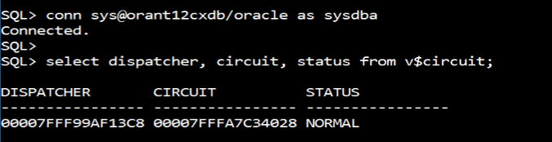

As opposed to the dedicated server service name “orant12c” that connects to the same orant12c instance
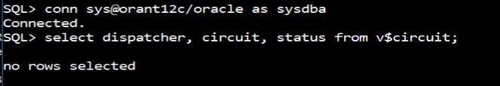

Error Message 3:

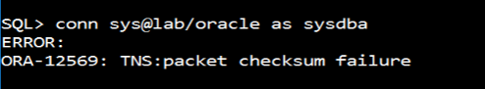
Solution: Check the port number of the net service name in tnsnames.ora file and make sure it match the protocol and port number an available listener
Error Message 4:
Solution: The host name is probably incorrect. Change the hostname then manually start the listener in windows services
Step 1: change host name from
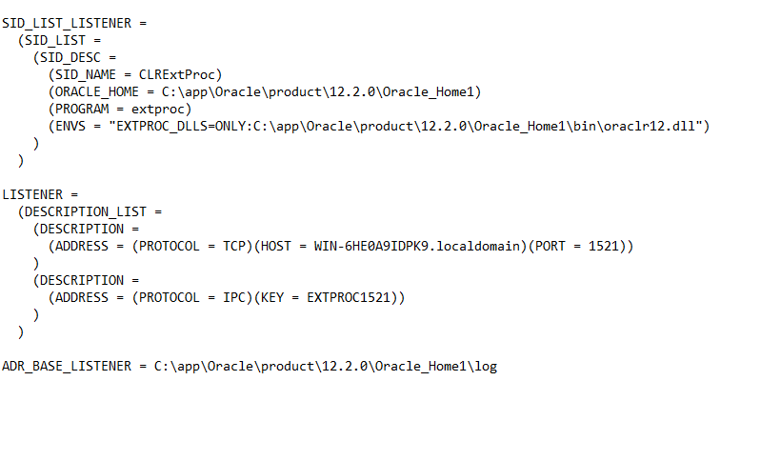
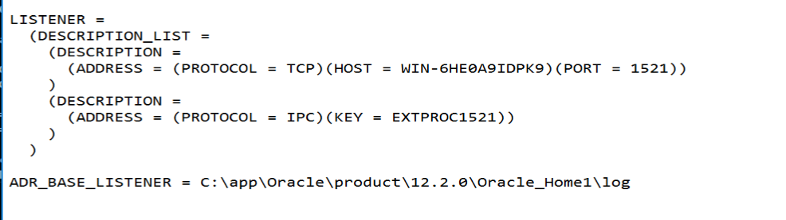

Step 2: Manually start the listener in windows services
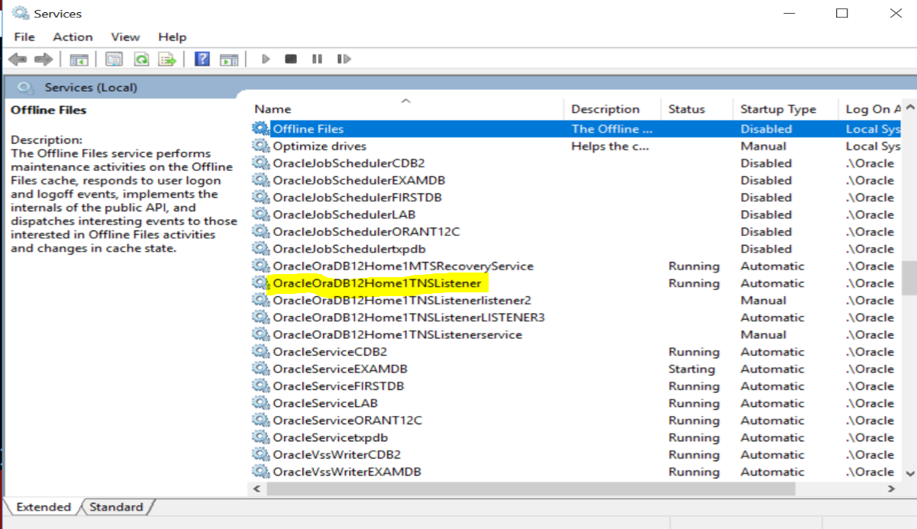
Step 3: Restart operating system

